**Bigfix Application Installation in Ubuntu System**

**PRE Step:**

1. Ensure Root Login is enabled in Ubuntu Endpoint
2. Incase Root login is not enable do the following steps
3. As the root user, edit the sshd_config file found in vi /etc/ssh/sshd_config



1. Add the following line to the file, you can add it anywhere but it’s good practice to find the block about authentication and add it there.

PermitRootLogin yes



1. Save and exit the file.
2. Restart the SSH by : systemctl restart sshd



1. Change the password of Root login by below command: passwd root



1. Change the password
2. Uninstall the BESCLIENT if client not installed through Root Login
3. Stop services of besclient by using : /etc/init.d/besclient stop

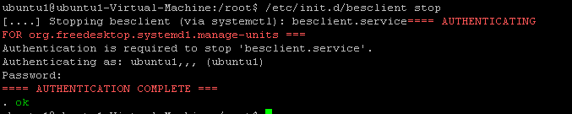

1. Uninstall the BESCLIENT by using : dpkg --purge BESAgent

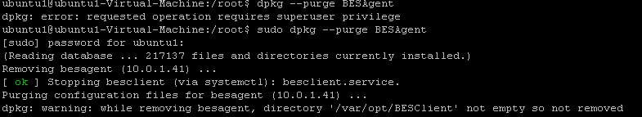

1. Bigfix Agent Installation should be run through only Root Login

**Process to Install Bigfix Client in Ubuntu System:**

1. Open File Folder -> Go to Other Location -> Connect to Server -> write in Search “ smb://172.16.3.10 -> Click on Connect button

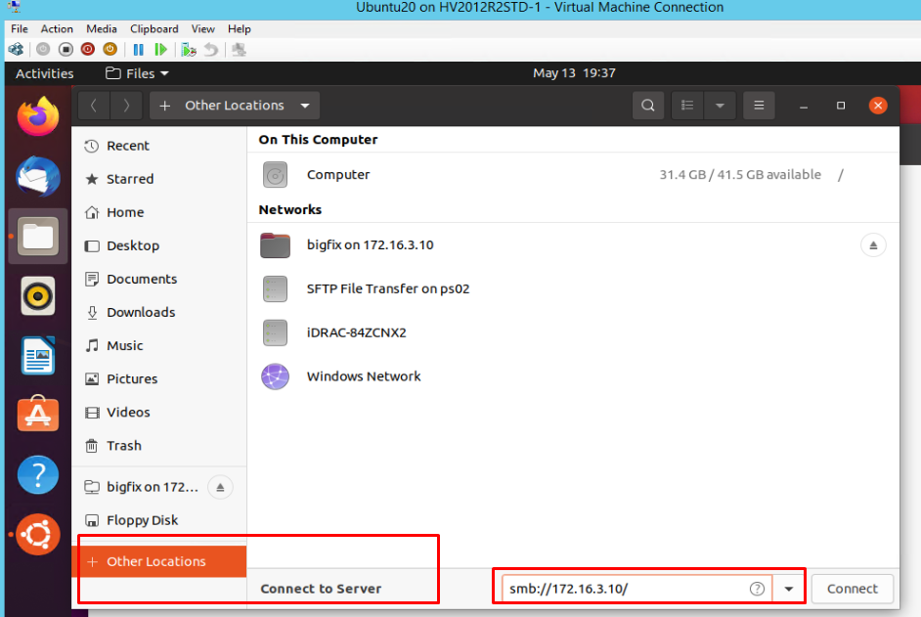

1. Enter AD Credential to login into server

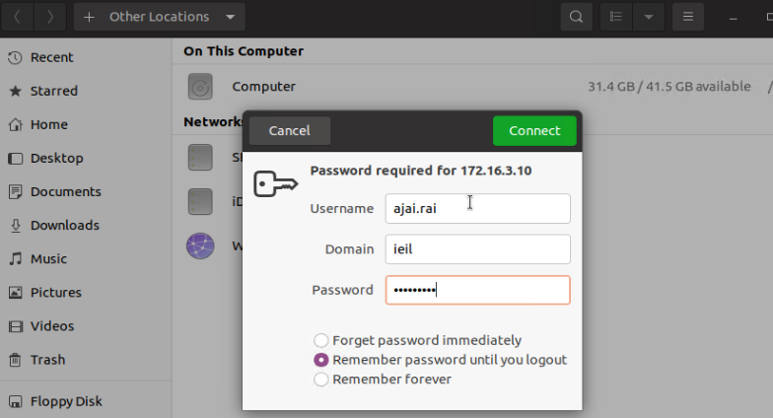

1. Copy and paste the setup file along with actionsite afxm from 172.16.3.10/Bigfix/Ubuntu on Ubuntu Endpoint

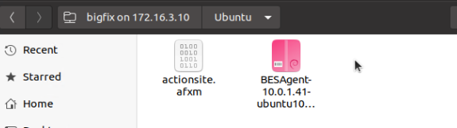

1. **Create a folder of BESClient in below location:** /etc/opt/BESClient
2. **Paste actionsite.afxm file to** /etc/opt/BESClient location
3. Install the deb file by right click on the file and click on Open with Software Install

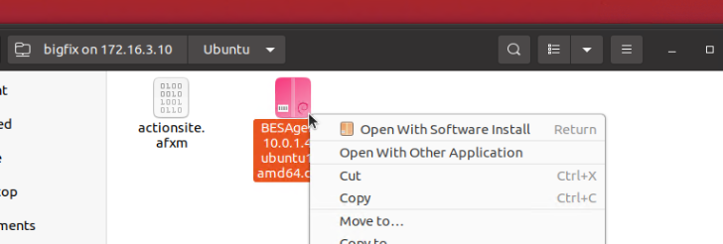

1. Start the BigFix Client by running the command: **/etc/init.d/besclient start**.
2. Installation of Bigfix Agent is completed successfully

UDP Connection Enable in Ubuntu Endpoint

1. Append below lines in

vim /etc/sysctl.conf

net.ipv6.conf.all.disable_ipv6 = 1

net.ipv6.conf.default.disable_ipv6 = 1

2. To make the settings affective, execute :

# sysctl -p

3. Add the AddressFamily line to sshd_config :

vi /etc/ssh/sshd_config

....

AddressFamily inet

....

Restart sshd for changes to get get effect :

systemctl restart besclient

# systemctl restart sshd

netstat –aul | grep 52311

output

